**SENet code**

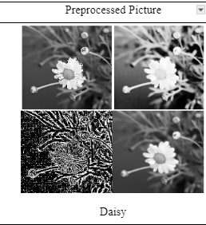

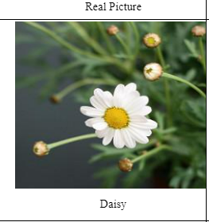

[Code based on 3669 Raw images](https://drive.google.com/file/d/13uE26ydyPKDfHB1wEAT0FIsczAQA66Dc/view?usp=sharing) [Code based on 14676 processed images](https://drive.google.com/file/d/1JivOME8qfr4FHPpcx3a8uW8bA9IIIbgI/view?usp=sharing)